Names: _____________________________________________________________________

Names: _____________________________________________________________________

238

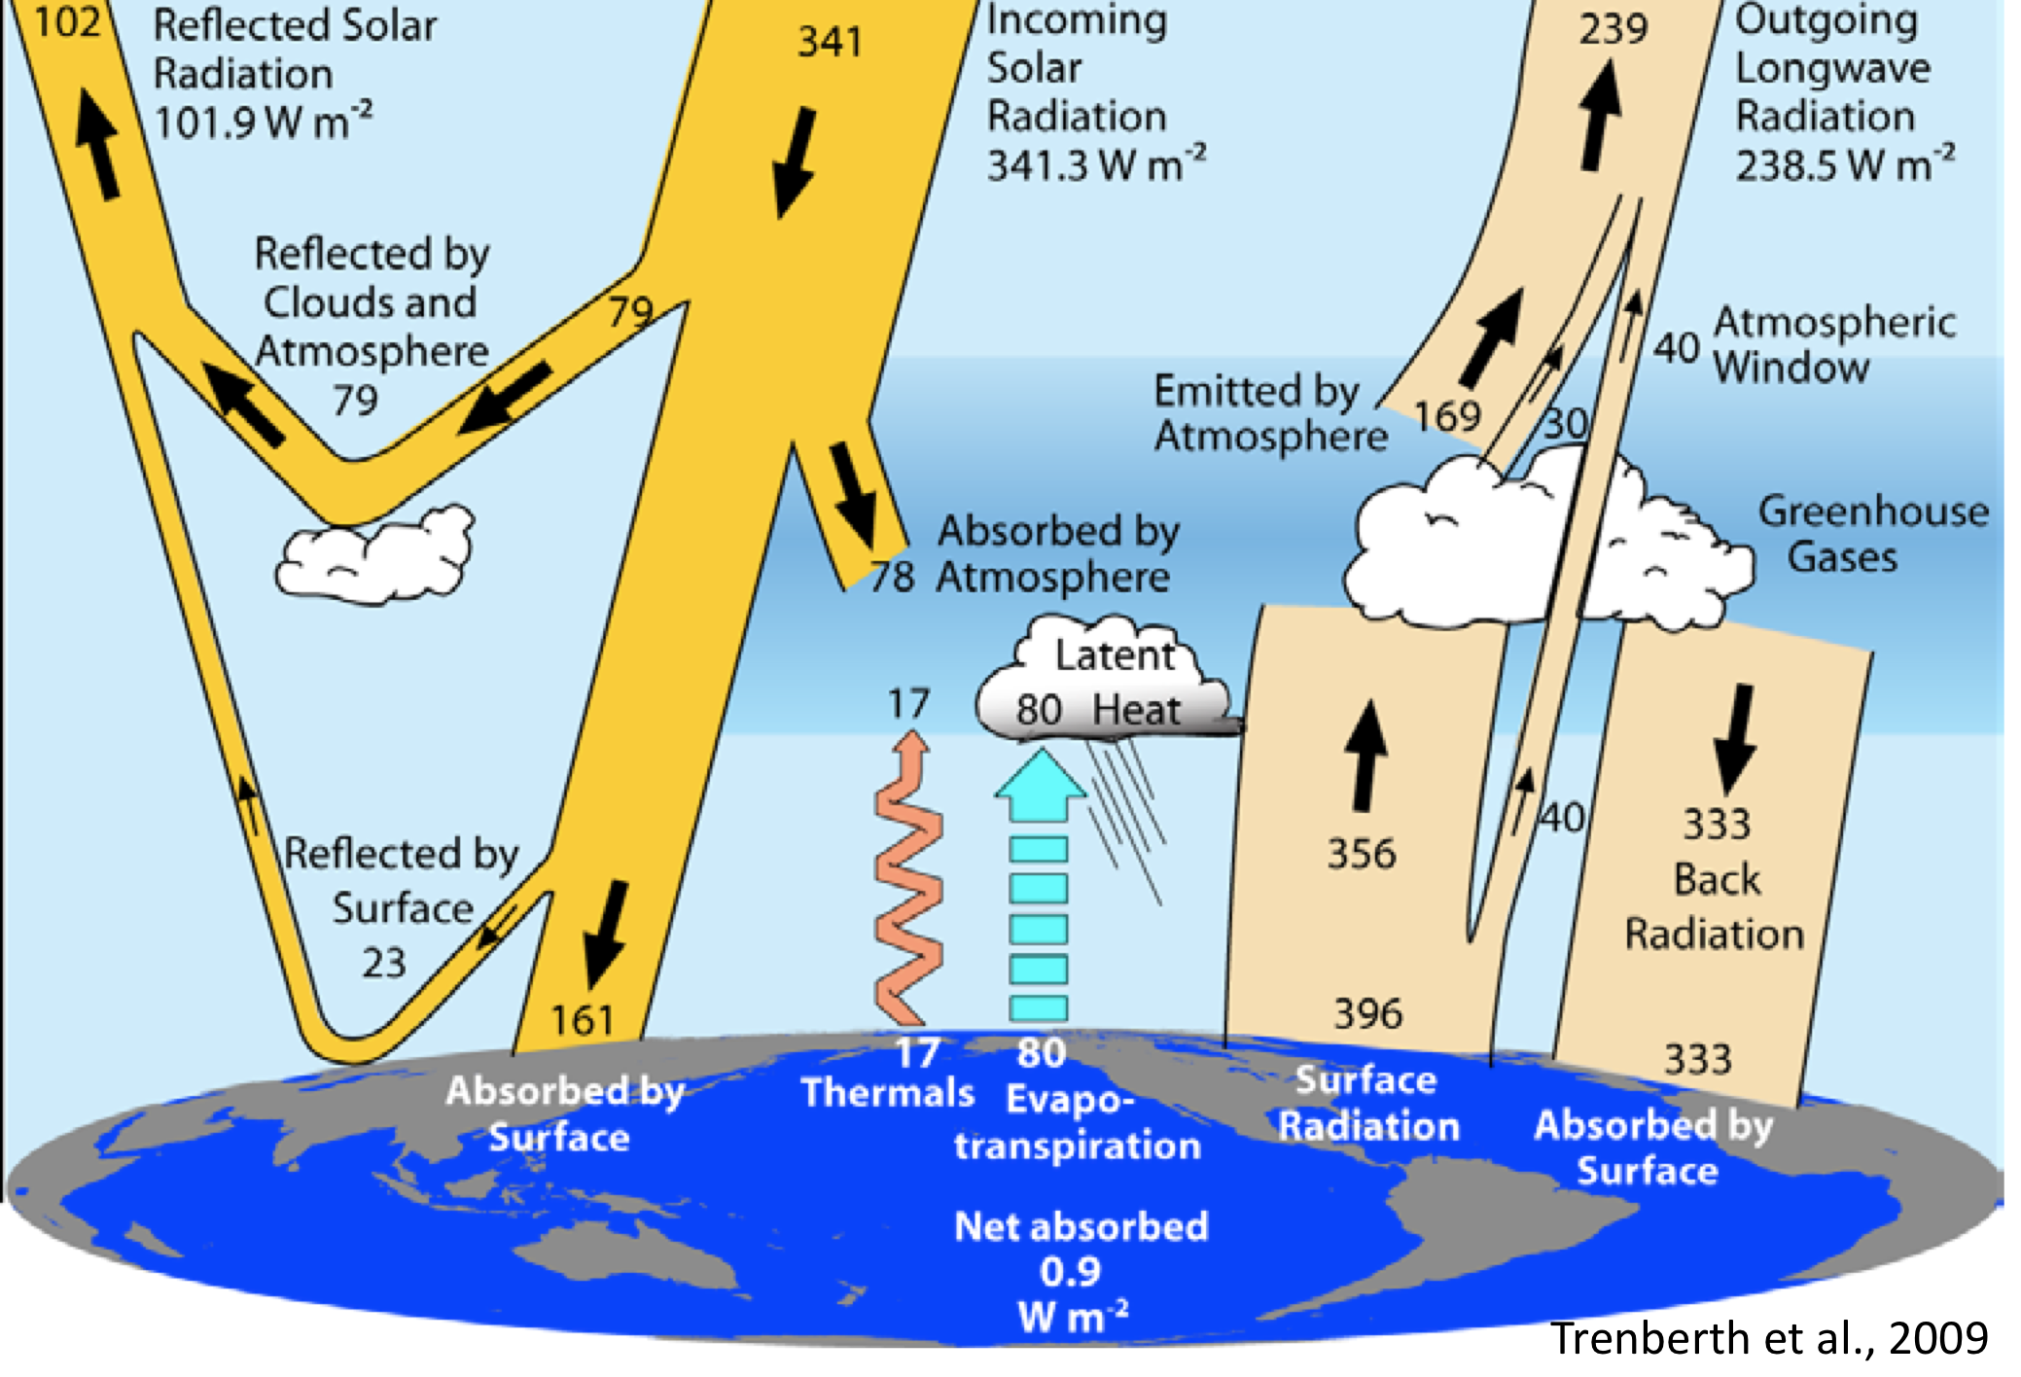

**1**

**2**

**3**

**184**

168

*modified*

**Earth’s Radiation Balance**

This diagram is a schematic highlighting the most important energy fluxes in the Earth’s climate system. We will see this worksheet many times over the course of the class. The black dotted lines artificially separate the system into three distinct layers. Use this diagram to answer the following questions.

1. What are the energy fluxes (including signs) entering the entire climate system from space (i.e. if you treat all three layers as one)? Identify the source(s) of these fluxes.

**341.3 Wm-2 from the sun**

1. What are the fluxes leaving the system? Do these balance the incident energy fluxes? Do you expect that the two should or should not be in balance? Explain.

**Fluxes leaving: -101.9 – 238.5 = -340.4**

**Be sure to use the convention that downward fluxes are positive and upward fluxes are negative!**

**difference Entering vs Leaving: 341.3 – 340.4 = 0.9 Wm-2 heating. Global warming is trapping 0.9 Wm-2**

1. Consider the “central” atmosphere, represented by layer 2. Identify all fluxes entering this layer, and all fluxes leaving this layer. Are incoming and outgoing fluxes in balance?

**At top of layer 2:**

-23 – 79 + 341 -238 = +1

**At the bottom of layer 2:**

-23 + 184 -17 -80 -396 + 333 = +1

**1 Wm-2 is coming in from the top and 1 Wm-2 is leaving from the bottom, so layer is neither heating or cooling**

1. Now consider layer 3 representing the earth’s surface. Again, identify all incoming and outgoing fluxes and determine if they are in balance.

161 – 17 – 80 – 396 + 333 = + 1 (heating)

**This follows the convention that downward fluxes are positive and upward fluxes are negative. So +1 would indicate a net downward flux into the surface.**

1. For the surface imbalance you found, how much would the surface temperature have to increase to restore balance? *Hint: recall that dE/dt = Iup+ Idnand treat the earth’s surface as a blackbody. Also recall the Stefan-Boltzman equation.*

**At the surface, the temperature needs to increase so that the upward surface flux changes from 396 to 397 Wm-2to restore balance.**

In [19]: Tbefore=(396/sigma)**0.25

In [20]: Tafter=(397/sigma)**0.25

In [21]: Tafter - Tbefore

Out[21]:

0.182

so temperature would need to increase by 0.18 K to restore equilibrium